Parish Income & Expenditure 2022  INCOME 2022 2021 € €  Donations and Bequests (inc. parish share of donations for baptisms, funerals and weddings) 27,476 23,587  Family Envelopes 38,261 34,214  Standing Orders 79,088 79,820  Tax Refund 28,694 27,983  Shrine Income 31,175 28,910  Insurance refund for Covid-19 income loss 13,606 -  Total Parish Income 218,300 194,514  The above income excludes income which is passed on directly to the Diocese (i.e. the two Church Collections and Dues)  EXPENDITURE  Shrine Expenses 10,797 9,264  Office Costs (including payroll and other fees, printing, telephone, postage, and equipment) 83,198 83,636  Facilities (heat, light, waste, insurance, security) 27,011 25,385  Bank Charges and Fees 1,408 1,245  Bank Interest Charged - 47  Altar Supplies 4,130 1,951  Other Expenses (music and sacrament related expenses) 15,226 7,172  Local Property Taxes 1,385 1,547  Repairs and Maintenance 58,619 29,665  Parish Hospitality and Catering 2,384 780  COVID-19 Expenditure and Related Costs - 1,801  Diocesan accounting system fees 2,095 1,936  Total Parish Expenditure 206,252 164,429  Operational Surplus for the year 12,048 30,085  Pastoral Centre Pledges (coming to an end) 9,914 17,955  Parish Bank Balance 57,177 47,448 | Notes to the 2022 Statement  Two collections are taken up during Masses i.e. The Priests Common Fund (2022 €59,698) from which the priests of the parish are paid, and SHARE (€45,038). These are paid directly to the Archdiocese and do NOT form part of parish income.  Dues monies received (€29,365) is lodged to the Priests Common Fund, which goes towards payment of salaries to priests in the Archdiocese. They are remitted in their entirety to the Archdiocese, and therefore do NOT form part of parish income.  Repairs and Maintenance expenses included the cleaning of the exterior of St Mary’s church, insulation and heating repairs at the parochial house, guttering and downpipes on the Presbytery and the wheelchair ramp re-construction at Ladychapel.  Parish Finance Committee  Fr Frank McEvoy, Fr Paul Kelly, Bernie O’Connor,  Brian Forristal, Ciarán Briody, Joe Travers,  Karen Kenny, Michael Gaffney, Senan Griffin  and Willie Holmes (Chairperson).  Thank You  We would like to express our deep appreciation for your continuing financial support in 2022. We have a credit bank balance of over €57,000, which allows us now focus on two major projects, namely the upgrade of the grounds in St Mary’s and, the appointment of a Parish Youth Leader, which we believe is a fundamental step forward for our parish. | Standing Order Set Up Form  Maynooth Parish  To the  Manager  Branch  Address  I /We hereby authorise and request you to debit my/our account  (details of the account from which payments will be made)  Account Name:  BIC  IBAN:  And to credit:  Maynooth Parish Number 1 Account  BIC: AIBKIE2D IBAN: IE98 AIBK 9332 0115 8890 08  Your Name (which will appear on our bank statement)  Your Address  Start Date  Frequency: Monthly  Amount:  .  Period: Open-Ended  Signature  Date  Signature (Joint)  Date  Contributions of €21 and over attract tax benefits for the Parish increasing your contribution by up to 45%.  - Please allow 5 working days prior to first payment.  - Please return completed form to Maynooth Parish, who will then send it to your Bank.
EASTER CEREMONIES  Palm Sunday: Blessing of Palms at all Masses  St Mary’s: 7.00 p.m. (Vigil) 8.45 a.m., 10.00 a.m.,  11.30 a.m. and 1.00 p.m.  Ladychapel: 10.00 a.m.  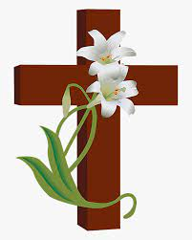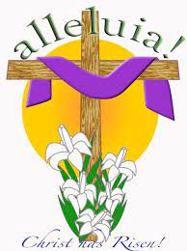  Holy Week Mon. – Wed.  Masses (St Mary’s) 10.00 a.m.  Holy Thursday:  St Mary’s: 10.00 a.m. – Morning Prayer  8.00 p.m. – Solemn Celebration of the Lord’s Supper  Followed by Watch & Pray (Music led by Folk Group)  Good Friday:  St Mary’s: 10.00 a.m. Morning Prayer  12.00 noon Children’s Stations of the Cross  3.00 p.m. Solemn Celebration of the Passion  of Our Lord. (Music led by St Mary’s Parish Choir)  8.00 p.m. St Mary’s - Stations of the Cross – followed by Prayer around the Cross  8.00 p.m. Ladychapel - Stations of the Cross  Holy Saturday: 10.00 a.m. - Morning Prayer  9.00 p.m. - Easter Vigil – Solemn Celebration of  the Lord’s Resurrection  (Music led by St Mary’s Parish Choir)  Easter Sunday  St Mary’s: 8.45 a.m., 10.00 a.m.,  11.30 a.m. and 1.00 p.m.  Ladychapel: 10.00 a.m. | Parish Contact Details:  Fr Frank McEvoy, P.P.  Tel: 01 6286220  Fr Paul Kelly, C.C.  Tel: 0872463876  Martina Kennedy  Tel: 6293018  Parish Office  Parish Pastoral Centre  Moyglare Road W23 N663  Mon, Tues & Thurs.  9.00 a.m. – 4.00 p.m.  Lunch 12.00 – 1.00  Wed. - 9.00 a.m. – 12.00  Mass Times St Mary’s Church  Weekday Mass: 10.00 a.m.  Saturday (Vigil)  7.00 p.m.  Sunday  8.45 a.m., 10.00 a.m., 11.30 a.m.  and 1.00 p.m.  Ladychapel - Sunday 10.00 a.m.  Live streaming available @ www.maynoothparish.org  Parish email: maynoothparishoffice@gmail.com | Maynooth Parish  St Mary's and Ladychapel  Financial Statement 2022  and Easter Ceremonies 2023  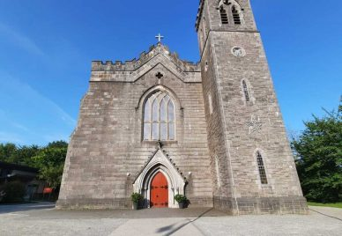  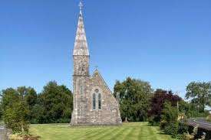  Special Notice  This year our key focus is to appoint a Parish Youth Leader to help promote the faith among young people. We are keen to make this major decision in the next couple of weeks. Please consider a regular monthly pledge by increasing your existing contribution, or by effecting a new standing order, using the attached form.  This will be a unique and vital service for the young people of Maynooth.

